42.50: a) 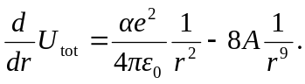
Setting this equal to zero when 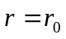gives
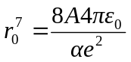
and so
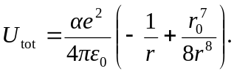
At 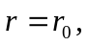
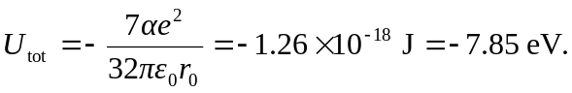
b) To remove a 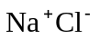ion pair from the crystal requires 7.85 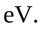When neutral Na and Cl atoms are formed from the 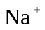and 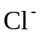atoms there is a net release of energy
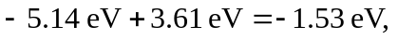so the net energy required to remove a neutral Na, Cl pair from the crystal is 